# ELECTRIC VEHICLE MARKET SEGMENTATION IN INDIA

Contributors: Rohan Jaiswar , Md Yasin , M.Dilip kumar

Rohan jaiswar

**Introduction**

The electric vehicle (EV) market in India is growing rapidly. In 2022, the market size was valued at USD 2.2 billion and is expected to reach USD 152.21 billion by 2030, growing at a CAGR of 94.4%. The growth of the EV market in India is being driven by a number of factors, including:

* Government incentives: The Indian government has introduced a number of incentives to promote the adoption of EVs, including tax breaks, subsidies, and exemptions from registration fees.
* Rising fuel prices: The rising cost of fuel is making EVs more attractive to consumers.
* Increasing environmental awareness: There is growing awareness among consumers about the environmental benefits of EVs.
* Improved technology: The technology of EVs has improved significantly in recent years, making them more affordable and efficient.

The EV market in India is still in its early stages, but it is growing rapidly. The two-wheeler segment is the largest segment of the EV market in India, followed by the three-wheeler segment. The passenger car segment is also growing rapidly, and is expected to become the largest segment of the market by 2030.

The growth of the EV market in India is creating new opportunities for businesses. There is a growing demand for EV components, such as batteries, motors, and chargers. There is also a growing demand for EV services, such as charging infrastructure and fleet management. The government has set a target to achieve 30 percent electrification of the country's vehicle fleet by 2030.

Here are some of the key trends that are shaping the EV market in India:

* The growth of the two-wheeler and three-wheeler segments: These segments are expected to continue to grow rapidly in the coming years, as they are the most affordable and accessible forms of EVs.
* The increasing popularity of passenger cars: The passenger car segment is growing rapidly, as consumers are becoming more aware of the environmental benefits of EVs.
* The growth of the commercial vehicle segment: The commercial vehicle segment is also growing rapidly, as businesses are looking to reduce their operating costs by switching to EVs.
* The development of charging infrastructure: The development of charging infrastructure is essential for the growth of the EV market in India. The government is taking steps to develop charging infrastructure, and private companies are also investing in this area.
* The growth of the EV component manufacturing industry: The growth of the EV market in India is creating new opportunities for businesses in the EV component manufacturing industry.

The EV market in India is a rapidly growing market with significant potential. The government is taking steps to promote the adoption of EVs, and the private sector is also investing in this area. The growth of the EV market in India is creating new opportunities for businesses in a variety of sectors.

**Problem Statement**

An EV startup is developing electric vehicles (EVs) and are trying to decide which vehicle/customer space to target. The Indian EV market is growing rapidly, but it is still in its early stages. There are a number of different segments in the market, each with its own unique characteristics. We need to analyze the market and identify the segments that are most likely to adopt EVs. We also need to develop a feasible strategy to enter the market and compete in these segments.

The Indian EV market can be segmented based on the following criteria:

* **Vehicle type**: The EV market can be segmented into two-wheelers, three-wheelers, passenger cars, and commercial vehicles. Two-wheelers are the most popular type of EV in India, followed by three-wheelers. Passenger cars and commercial vehicles are still in the early stages of development.
* **Customer**: The EV market can also be segmented by customer type. Customer behavioural data can be used to perform market segmentation.

**Data Sources**

To perform the market segmentation for the EV market we will analyze three datasets with the following sources:

* Charging Stations in India: [https://www.kaggle.com/datasets/saketpradhan/electric-](https://www.kaggle.com/datasets/saketpradhan/electric-vehicle-charging-stations-in-india) [vehicle-charging-stations-in-india](https://www.kaggle.com/datasets/saketpradhan/electric-vehicle-charging-stations-in-india)
* EV Population Data of USA: [https://catalog.data.gov/dataset/electric-vehicle-](https://catalog.data.gov/dataset/electric-vehicle-population-data) [population-data](https://catalog.data.gov/dataset/electric-vehicle-population-data)
* Indian Automobile Buying Behaviour: [https://www.kaggle.com/datasets/karivedha/indian-consumers-cars-purchasing-](https://www.kaggle.com/datasets/karivedha/indian-consumers-cars-purchasing-behaviour) [behaviour](https://www.kaggle.com/datasets/karivedha/indian-consumers-cars-purchasing-behaviour)

**Analysis of Charging Stations in India**

The columns in the dataset are:

* **name**: The name of the charging station
* **state**: The state where the charging station is located
* **city**: The city where the charging station is located
* **address**: The address of the charging station
* **lattitude**: The latitude of the charging station
* **longitude**: The longitude of the charging station
* **type**: The type of charging station (slow, fast, or ultra-fast)

**Data Preprocessing**

The following data pre-processing steps using pandas library were done on the dataset:

1. The data had 205 duplicate entries which were dropped from the dataset.
2. Rows with missing values were removed.
3. A new variable **charging_speed** was created using the **type** variable.
4. There was some bad data in the **latitude** and **longitude** variables which were cleaned.
5. There were some duplicate and incorrect **state** and **city** names which were cleaned.

**Inferences from the EDA**

* The distribution of charging stations in India is uneven, with the majority of stations located in the states of Maharashtra, Delhi, and Tamil Nadu.
* The city with the highest number of charging stations is New Delhi, followed by Bangalore and Chennai. These cities are all major metropolitan areas with a high demand for electric vehicles.
* Most of the charging stations in India provide slow charging for EVs, while there are very few ultra-fast charging stations. This is likely due to the high cost of ultra-fast chargers.
* Karnataka has the highest number of fast charging stations in India, followed by Maharashtra and Telangana. Bangalore has the highest number of fast charging stations in India.
* Tamil Nadu and Maharashtra have the highest number of ultra-fast charging stations in India, followed by Telangana and Karnataka. Hyderabad has the highest number of ultra-fast charging stations in India.

These observations suggest that the demand for electric vehicles is highest in the major metropolitan areas of India. The government of India should focus on developing charging infrastructure in these areas to support the growth of the electric vehicle market.

**Analysis of EV Population Data**

The dataset includes the following columns:

* **VIN (1-10)**: The vehicle identification number (VIN) of the electric vehicle.
* **County**: The county where the electric vehicle is registered.
* **City**: The city where the electric vehicle is registered.
* **State**: The state where the electric vehicle is registered.
* **ZIP Code**: The ZIP code where the electric vehicle is registered.
* **Model Year**: The model year of the electric vehicle.
* **Make**: The make of the electric vehicle.
* **Model**: The model of the electric vehicle.
* **Electric Vehicle Type**: The type of electric vehicle, such as battery electric vehicle (BEV) or plug-in hybrid electric vehicle (PHEV).
* **Clean Alternative Fuel Vehicle (CAFV) Eligibility**: Whether the electric vehicle is eligible for Clean Alternative Fuel Vehicle (CAFV) incentives.
* **Electric Range**: The electric range of the electric vehicle in miles.
* **Base MSRP**: The base manufacturer's suggested retail price (MSRP) of the electric vehicle in US dollars.
* **Legislative District**: The legislative district where the electric vehicle is registered.
* **DOL Vehicle ID**: The vehicle identification number assigned by the Department of Licensing (DOL) of the state of Washington.
* **Vehicle Location**: The location of the electric vehicle, represented as a point in geographic coordinates.

**Data Preprocessing**

The following data pre-processing steps using pandas library were done on the dataset:

1. Rows with missing values were removed.

**Inferences from the EDA**

* The electric vehicle (EV) market in the United States has seen significant growth in recent years, with battery electric vehicles (BEVs) accounting for the majority of EVs sold.
* The number of EVs made in the US has increased exponentially over the past 13 years, with BEVs leading the way. PHEVs have also seen growth, but not as drastic as BEVs.
* Tesla is the leading manufacturer of EVs in the US, accounting for nearly half of all EVs sold since 1997.
* More than 60,000 EVs are eligible for clean alternative fuel (CAF) incentives, while another 60,000 have not yet been researched to determine eligibility.
* Most of the electric vehicles have an electric range that is clustered between 20 to 40 miles and 200 to 250 miles. PHEVs, in general, have a lower range than BEVs.

These observations suggest that the EV market in the US is growing rapidly, with BEVs leading the way. Tesla is the dominant manufacturer of EVs in the US, and a significant number of EVs are eligible for CAF incentives. However, there is still a lack of data on the electric range of many EVs.

**Analysis of Indian Automobile Buying Behaviour Data**

The dataset includes the following columns:

* **Age**: The age of the buyer.
* **Profession**: The occupation of the buyer.
* **Marital Status**: The marital status of the buyer.
* **Education**: The highest level of education of the buyer.
* **No of Dependents**: The number of dependents of the buyer.
* **Personal loan**: Whether the buyer has a personal loan.
* **House Loan**: Whether the buyer has a house loan.
* **Wife Working**: Whether the wife of the buyer is working.
* **Salary**: The salary of the buyer.
* **Wife Salary**: The salary of the wife of the buyer.
* **Total Salary**: The combined salary of the buyer and wife.
* **Make**: The make of the automobile purchased.
* **Price**: The price of the automobile purchased.

**Data Preprocessing**

The following data pre-processing steps using pandas library were done on the dataset:

1. The Wife Working variable had one extra category with only one data point. This category was merged with the Yes category.

**Inferences from the EDA**

* The salary of the customers is grouped around 1000000 and 2500000 Indian rupees. This suggests that the majority of the customers in the dataset are from the upper- middle class or upper class.
* Wife's salary for most of the customers is zero. For those whose wife is working, the salary is between 500000 and 1500000 Indian rupees.
* The total household salary of the customer is between 1000000 and 3000000 Indian rupees. This suggests that the majority of the customers in the dataset have a comfortable financial situation.
* The price of the cars purchased by the customers range between 500000 and 2000000 Indian rupees. This suggests that the majority of the customers in the dataset have purchased mid-range cars.
* Around 65% of the customers are salaried while 35% have their own business. This suggests that the majority of the customers in the dataset are employed professionals.
* Most of the customers in the dataset are married. This suggests that the majority of the customers in the dataset are in a stable family situation.
* Around 55% of the customers hold a post-graduate degree while 35% have a graduate degree. This suggests that the majority of the customers in the dataset are well- educated.
* Most of the customers have 3 and 2 dependents. This suggests that the majority of the customers in the dataset have young families.
* Around 68% of the customers do not have a personal loan. This suggests that the majority of the customers in the dataset are able to afford the cars they have purchased without taking out a loan.
* Around 61% of the customers do not have a house loan. This suggests that the majority of the customers in the dataset are able to afford to buy a house without taking out a loan.
* Around 52% of the customer's wives are working. This suggests that the majority of the wives of the customers in the dataset are employed.
* Most of the customers have purchased SUV and Baleno followed by Creata. Very few customers have bought Luxury. This suggests that the majority of the customers in the dataset are interested in practical and fuel-efficient cars.

**Market Segmentation**

We will perform the EV Market Segmentation on the Indian Automobile Buying Behaviour dataset.

**Data Preprocessing**

The following data pre-processing steps using pandas and sklearn libraries were done on the segmentation dataset:

1. The categorical variables were one-hot encoded using the pd.get_dummies method.
2. The continuous variables were scaled using MinMaxScaler so that their values lie between 0 and 1.

**KMeans Clustering**

Here we use the K-means clustering algorithm to segment the car buyers into different groups. The K-means algorithm is a simple and efficient algorithm that can be used to cluster data points into a predefined number of groups.

The K-means algorithm works by iteratively assigning data points to the cluster with the closest mean. The algorithm then recomputes the means of the clusters and repeats the process until the clusters no longer change.

The K-means algorithm is able to find patterns in data that are not easily visible to the naked eye. The algorithm was able to identify the similarities and differences between different clusters, which allowed me to better understand the different types of car buyers.

**Elbow Plot**

To determine optimum number of clusters, Elbow Plot can be used. In this plot, the number of clusters are on the X-axis and the corresponding within-cluster sum of squares (WSS) are on the Y-axis.

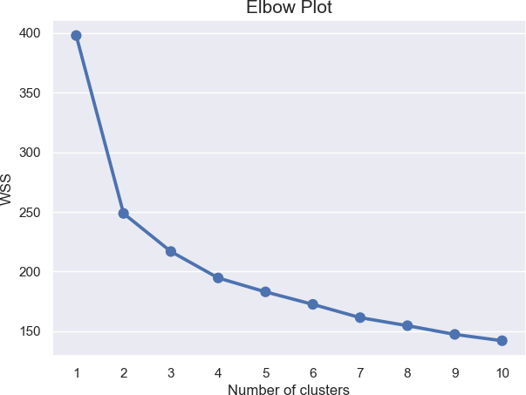

*Figure 1: Elbow Plot*

From the above plot we see that, the drop in WSS for clusters 1 to 2 is very large. But, the drop from clusters 2 to 3 is not significant. After cluster 3 the curve gets flatter. Therefore, the plot suggests the optimal number of clusters as 2.

**Silhouette Plot**

Silhouette method measures how tightly the observations are clustered and the average distance between clusters. For each observation a silhouette score is constructed which is a

function of the average distance between the point and all other points in the cluster to which it belongs, and the distance between the point and all other points in all other clusters, that it does not belong to.

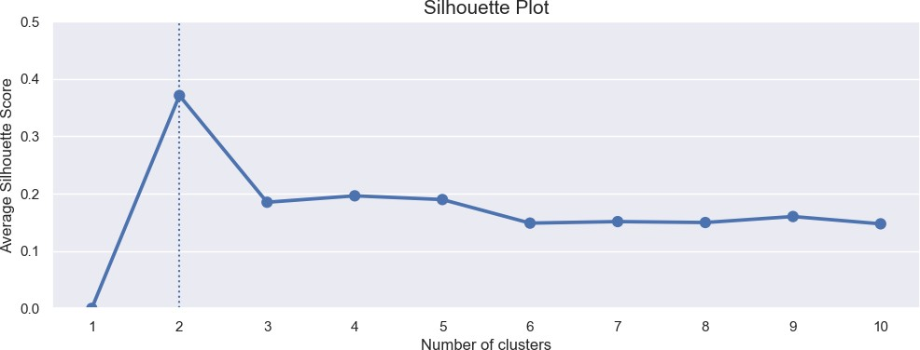

*Figure 2: Silhouette Plot*

From the above Silhouette Plot, we see that the silhouette score for 2 clusters is maximum. The Elbow method also suggested the optimal number of clusters as 2. Therefore, we choose optimal number of clusters as 2 and perform final segmentation using k equal to 2.

**Visualizing the Clusters using PCA**

To visualize the clusters, Principal Component Analysis was used to reduce the dimensionality 2. The scatter plot with color coding using the 2 cluster labels is shown below. From the below figure we see that; both the clusters are well separated from each other. The yellow cluster has fewer data points than the purple cluster.

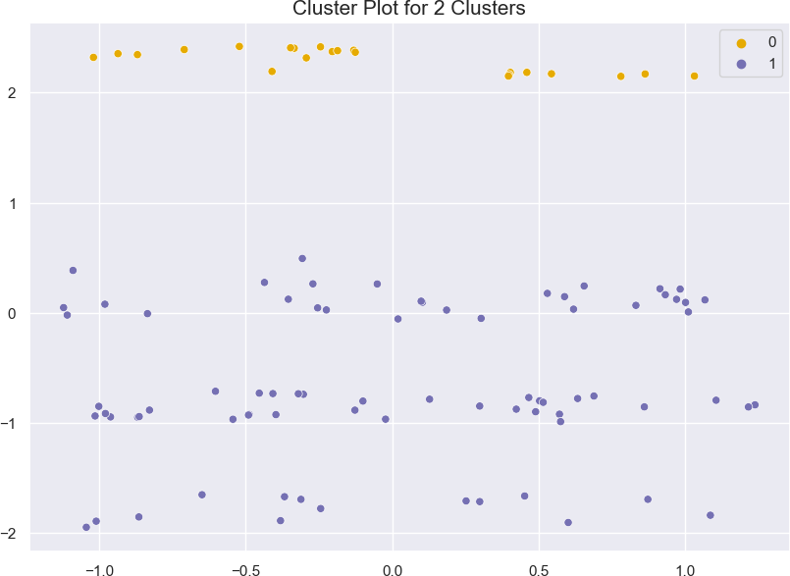

**Profiling the segments**

*Figure 3: Cluster Plot for 2 Clusters*

In the below table, we summarize the 2 clusters using the variables in the dataset.

|  |  |  |
| --- | --- | --- |
| **Feature** | **Cluster 1** | **Cluster 2** |
| **Average age** | 30 | 40 |
| **Most common profession** | Salaried | Salaried |
| **Marital status** | Single | Married |
| **Level of education** | Post Graduate | Post Graduate |
| **Average number of dependents** | 0 | 3 |
| **Loan type** | No loan | No loan |
| **Wife working status** | No | Yes |
| **Average salary** | 1300000 | 1900000 |
| **Average wife salary** | 300000 | 600000 |
| **Average total salary** | 1600000 | 2500000 |
| **Most popular make of car** | Baleno, Ciaz, Creata | SUV |
| **Average price of car** | 1100000 | 1200000 |

*Table 1: Segment Profiles*

The top 4 variables/features that can be used to create most optimal market segments for the Indian car market are:

* **Age**: The age of the car buyer is a good predictor of their needs and wants. Younger buyers are more likely to be looking for affordable cars, while older buyers are more likely to be looking for expensive cars.
* **Income**: The income of the car buyer is another good predictor of their needs and wants. Buyers with higher incomes are more likely to be able to afford expensive cars.
* **Education level**: The education level of the car buyer is also a good predictor of their needs and wants. Buyers with higher education levels are more likely to be looking for cars that are fuel-efficient and environmentally friendly.
* **Family size**: The family size of the car buyer is also a good predictor of their needs and wants. Buyers with larger families are more likely to be looking for cars that are spacious and comfortable.

These are just a few of the variables/features that can be used to create market segments for the Indian car market. By carefully considering these factors, car manufacturers can create products that meet the needs of different types of buyers.

**Conclusion**

As you can see, the two clusters are quite different in terms of their demographics and purchase behaviour. Cluster 1 is made up of younger, less well-off professionals who are looking for affordable cars. Cluster 2 is made up of middle-aged, well-off professionals who are looking for expensive cars.

Here are some of the key differences between the two clusters:

* Age: The average age of the buyers in Cluster 1 is 30, while the average age of the buyers in Cluster 2 is 40. This suggests that Cluster 1 is made up of younger professionals, while Cluster 2 is made up of more experienced professionals.
* Income: The average total salary of the buyers in Cluster 1 is 1600000, while the average total salary of the buyers in Cluster 2 is 2500000. This suggests that Cluster 1 is made up of less well-off professionals, while Cluster 2 is made up of more well-off professionals.
* Car preference: The most popular make of car in Cluster 1 is Baleno, Ciaz, and Creata, which are all relatively affordable cars. The most popular make of car in Cluster 2 is SUV, which are typically more expensive cars.

These differences suggest that the two clusters are looking for different things in a car. Cluster 1 is looking for an affordable car that is reliable and fuel-efficient. Cluster 2 is looking for a more luxurious and powerful car that can accommodate their families.

**Marketing Mix**

The ideal target segment for the EV startup entering the Indian market would consist of younger, less well-off professionals who are looking for affordable cars. This segment is the largest and fastest-growing segment in the Indian EV market. These buyers are more likely to be price-sensitive, so the EV startup should focus on offering an affordable EV that meets their needs.

The marketing mix for this segment would focus on the following elements:

* **Product**: The EV should be affordable, efficient, and stylish. It should also have a range that is suitable for the Indian driving conditions.
* **Price**: The price of the EV should be competitive with other EVs in the market. However, it should also be affordable for the average Indian consumer. The EV should be priced so that it is accessible to a wide range of potential buyers.
* **Place**: The EV should be available in a variety of dealerships across India. The dealerships should be located in urban and semi-urban areas where there is a demand for EVs. The dealerships should also be equipped with charging stations so that buyers can easily charge their EVs.
* **Promotion**: The EV should be promoted through a variety of channels, including online and offline marketing. Online marketing should be used to reach a wide audience. Offline marketing should be used to reach potential buyers in urban and semi-urban areas. The promotion should focus on the benefits of EVs, such as their environmental friendliness and affordability.
* **People**: The EV startup should hire a team of experienced professionals who are passionate about EVs. The team should be able to understand the Indian market and develop a marketing strategy that is effective in reaching potential buyers.
* **Process**: The EV startup should have a smooth and efficient sales process. The process should be easy for buyers to understand and follow. The startup should also provide excellent customer service to ensure that buyers are satisfied with their purchase.
* **Physical Evidence**: The EV startup should create a physical presence that is consistent with the brand. The dealerships should be well-designed and should reflect the company's commitment to quality. The EV itself should be well-designed and should meet the expectations of potential buyers.

This marketing mix would be effective in reaching the target segment and convincing them to purchase an EV. The EV startup would need to tailor the marketing message to the specific needs and interests of the target segment. For example, the marketing message could focus on the environmental benefits of EVs or the affordability of the EV.

The EV startup would also need to make sure that the EV is available in dealerships that are convenient for the target segment. The dealerships should be located in urban and semi-urban areas where the target segment lives and works. The dealerships should also be equipped with charging stations so that buyers can easily charge their EVs.

By following these marketing strategies, the EV startup would be well-positioned to succeed in the Indian EV market.

**Further Possible Improvement**

Given additional time and budget, the market segmentation project can be improved in the following ways:

* Collect additional data points, such as the car buyers' satisfaction, ratings for different EV features, etc.
* Try additional ML models, such as the hierarchical clustering algorithm and the Gaussian mixture model.
* Conduct a more detailed analysis of the data, such as a chi-squared test or a discriminant analysis.

MD YASIN :-

*Abstract*

Thisproject presents acomprehensive analysisof India'selectricvehiclemarket, focusing on segmentation derived from sales data, customer reviews, and technical specifications. The study highlights the robust growth trajectory of India's two-wheeler market, establishing it as a primary revenue source. Utilizing behavioral variables from customer reviews, a rigorous marketsegmentationanalysiswasconductedemployingthestandardk-meansalgorithm.The analysis effectively partitioned the market into four distinct segments.

Segment1emergesasthecornerstoneofourstrategy,constitutingasubstantial39%ofthe consumer base.This segment not only represents a substantial market opportunity but also serves as the optimal target for our venture. The analysis guides the recommendation of

specificelectrictwo-wheelertechnicalspecificationstailoredtomeetthepreferencesof Segment 1 consumers.

The recommended specifications, seamlessly integrating with the demands of this segment, arepivotaltoourapproach.Moreover,thepricerangealignscloselywiththemedianvalues, ensuring affordability and competitiveness. This strategic alignment with Segment 1,

identifiedasthepotentialearlymarketcustomerbase,positionsourventureoptimallywithin India's electric vehicle landscape.

# Introduction

Indiaisexperiencingasignificantshift initstransportationlandscape,drivenby the

widespread adoption of Electric Vehicles (EVs). The nation's rapid urbanization, growing population,andincreasedincomelevelshavefueledtheembraceofEVsasaneco-friendly alternative.Among these, electric two-wheelers have emerged as pioneers due to their affordability and wide consumer acceptance.These vehicles are reshaping India's mobility narrative, offering a sustainable solution to the challenges of pollution and greenhouse gas emissions.

TheIndiangovernmenthasplayedavitalroleinfosteringthischange,implementingpolicies that encourage local manufacturing and support a robust network of manufacturers, dealers, and service providers. In 2023, the electric two-wheeler market in India has reached a

pinnacle,symbolizingthesuccessoftheseeffortsandthegrowingacceptanceofclean mobility solutions.

Thisstudydelvesintotheheartofthistransformation,focusingontheelectricvehicle industry with a specific emphasis on electric two-wheelers. By combining behavioral

segments,psychographicdata,anddetailedvehiclespecifications,weprovideinformedEV pricerecommendations.Thisholistic approach aimsto empower consumers, policymakers, and industry stakeholders alike. By understanding the diverse facets of consumer behavior and preferences, this study illuminates the path toward a sustainable, environmentally

conscious,andconsumer-centricelectrictransportationsysteminIndia.

# ProblemStatementandFermiEstimation

## ProblemStatement

ThechallengeathandistostrategicallypositionourElectricVehicleStartupintheIndian market by utilizing data-driven insights derived from sales data, customer reviews

(encompassingbehavioralandpsychographicdata),andtechnicalspecificationsofelectric vehicles. Our objective is to employ these insights to effectively segment the market and

recommendtargetsegmentsforourelectricvehicles.

## FermiEstimation

### DataCollectionandAssessment

* + - * Gathersalesdata,electricvehicle customerreviews,andtechnicalspecifications.
      * Evaluatethereliabilityandcomprehensivenessofthecollecteddata.

### SegmentationUsingBehavioralVariables

* + - * Utilizebehavioraldatato identifypatternsandsegmentswithinthecustomerbase.
      * Estimatethesizeandcharacteristicsofeachsegmentusingdata-driven techniques.

### AnalysisofPsychographicData

* + - * Analyzepsychographicdatawithineachbehavioralsegmenttodiscerncustomer preferences and motivations.
      * Estimatethepsychographictraitsandpreferences ofcustomerswithineachsegment.

### TechnicalSpecificationandPriceAnalysis

* + - * Evaluatetechnicalspecificationsofelectricvehicleswithinidentifiedsegments.
      * Estimatetheimpactoftechnicalfeaturesoncustomerpreferencesandpurchasing decisions.

### TargetSegmentSelection

* + - * Selecttargetsegmentsbasedonathoroughanalysisofbehavioral,psychographic,and technical factors.

### CustomizationofMarketingMix

* + - * Developacustomizedmarketingmixtailoredspecificallyfortheselectedtarget segments.
      * Estimatetheeffectivenessofvariousmarketingstrategieswithintheselectedtarget segments, aligning them with customer preferences.

### SegmentRecommendation

* + - * Combinesegmentanalysisresultsandmarketingmixcustomizationfindingsto finalize segment recommendations.
      * Recommendtargetsegmentswiththehighestestimatedmarketpotential,ensuringa focused and targeted market entry strategy.

By following these systematic steps, employing Fermi estimation at each stage, our Electric VehicleStartupaimstomakeinformeddecisions,preciselytargetmarketsegments,andtailor our marketing approach to meet the unique demands and preferences of our customers, ensuring a successful market entry and sustained growth.

# DataSourcesandCollection

Forthisproject,datawasgatheredfromthreedistinctsources.Theprimarydataset,obtained from the Society of Manufacturers of Electric Vehicles, spanning 2017 to 2023, catalogues

salesfiguresofelectrictwo-wheelers,three-wheelers,four-wheelers,andbuses1.Thisdataset provides a comprehensive view of market trends and customer preferences over time.

Theseconddataset,extractedfrombikewale.com,compriseselectrictwo-wheelercustomer reviews, offering vital behavioral and psychographic insights2. These qualitative inputs

provedinvaluableinunderstandingcustomer behavior.

Lastly, thethird dataset from bikewale.com presentsdetailed technical specificationsand pricinginformationofelectrictwo-wheelers2.Thisdataallowedustoassessthetechnical feasibility and price points crucial for our market segmentation strategy.

Byintegratingthesedatasets,arobustunderstandingoftheelectricvehiclemarketwas developed. Real sales data, customer sentiments, and technical specifics formed the

foundationofouranalysis,ensuringadata-driven,market-relevantsegmentation approach.

# DataPre-processing

Thedatapre-processingphaseofthisprojectinvolvedasystematicapproachfacilitatedby Pythonlibrariesincludingnumpy,pandas,matplotlib,seaborn,andnltk.Thefirsttaskwas handling the sales data, initially distributed across 10 separate sheets in Excel format.

Utilizingpandas,thedatasheetsweremergedintoaunifieddataset,settingthefoundationfor subsequent analysis.Akey focus was placed on ensuring the accuracy of electric vehicle

makernames,achievedthroughmeticulousreplacement operations.

Followingthedataconsolidation,essentialaggregationoperationswereperformedonelectric two-wheeler sales data. This step provided a detailed perspective on market trends. The

subsequentphasecenteredondatapreparationformarketsegmentation.Customerreviews andresponsesweremergedwithcorrespondingelectricvehicletechnicalspecifications.To maintain data integrity, null values were handled using specific logical values, ensuring a complete dataset.

Sentimentanalysisofcustomerreviewswasconductedusingthenaturallanguageprocessing capabilities of nltk. This analysis provided valuable qualitative insights into customer

sentiments.Subsequently,behavioralvariablessuchasVisualAppeal,Reliability,

Performance,ServiceExperience,ExtraFeatures,Comfort,MaintenanceCost,andValuefor Moneywereisolatedandmeticulouslyprepared.Thesevariableswerefundamentalinlaying the groundwork for the market segmentation analysis, providing a nuanced understanding of customer preferences and attitudes toward electric vehicles.

# SegmentExtraction

## UsingSalesData

Inthissegment,adetailedanalysiswasconductedbasedonthreesignificantfigures representing India's electric vehicle market.

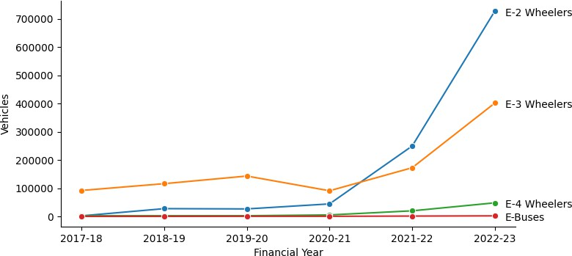

### Figure5.1India’selectricvehiclemarket

Figure5.1showcasedtheremarkablegrowthtrajectoryofIndia'stwo-wheelermarketin 2023, underscoring its leading position within the industry.

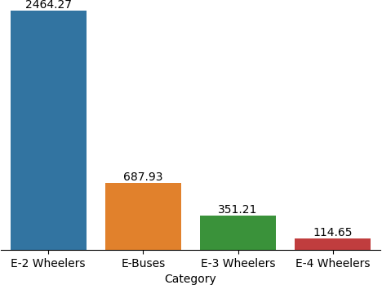

### Figure5.2India’selectricvehicleindustryin crores

Figure5.2delvedintothemarket'sfinancialperspective,representingtheindustry'stotal value in crores. Notably, two-wheelers emerged as the primary revenue generators,

highlightingtheireconomic significance.

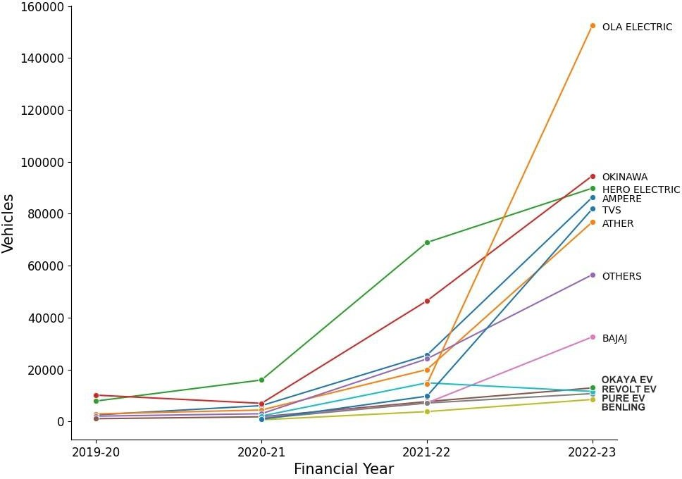

### Figure5.3Topelectrictwo-wheelercompanies

Figure5.3honedinonspecificelectrictwo-wheelercompanies,withOlaElectricemerging as the market leader in 2023, illustrating industry leadership and market competitiveness.

Upon in-depth analysis of these figures, it became evident that the electric two-wheeler segmentwasthemostpromisingareaforourdetailedstudy.Therobustgrowth,revenue dominance, and market leadership collectively indicated its prominence and potential, making it the ideal focus for our detailed study.

## Usingk-Means

In this subsequent analysis, the standard k-means algorithm was applied to explore market segmentationpossibilitieswithintheelectrictwo-wheelercustomerreviewsdata.Solutions were systematically tested for two to eight market segments. The decision-making process was significantly guided by the scree plot Figure 5.4, revealing a distinct elbow at four

segments.Thismarkedpointindicatedasubstantialreductionindistances,signifyingthe

optimal numberof segmentsforour analysis. By incorporating insightsfrom theseanalyses, ourfocusremainedfinelytunedontheelectrictwo-wheelersegment,ensuringprecisionand relevance in our market segmentation approach.

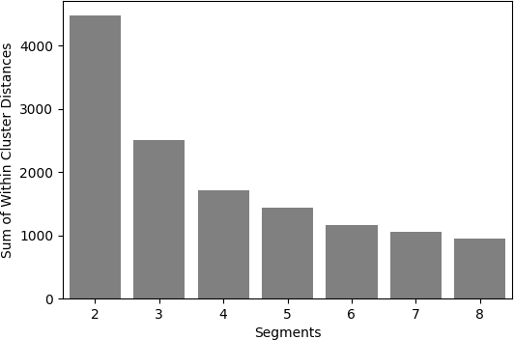

**Figure5.4Screeplotfortheelectricvehicledataset**

# ProfilingandDescribingSegmentation

## ProfilingSegments

Thissectionpresentsadetailedanalysisofourconsumersegments,asillustratedinFigure

6.1.Thegraphvisuallycapturesthediverseperceptionsamongdifferentsegments.Segment 0, representing 15% of consumers, values the electric two-wheeler vehicle for its visual

appeal, reliability, performance, service experience, and comfort. Conversely, Segment 1 (39% of consumers) expresses dissatisfaction across all aspects, marking them as the largest butleastsatisfiedgroup.Segment2(33%ofconsumers)appreciatesvisualappeal,reliability,

serviceexperience,comfort,andnotably,perceivesastrongvalueformoney.Lastly,Segment 3 (13% of consumers), the smallest segment, values visual appeal, reliability, performance,

serviceexperience,extrafeatures,andmaintenancecost,showcasingdistinctperceptions, particularly on features and costs.

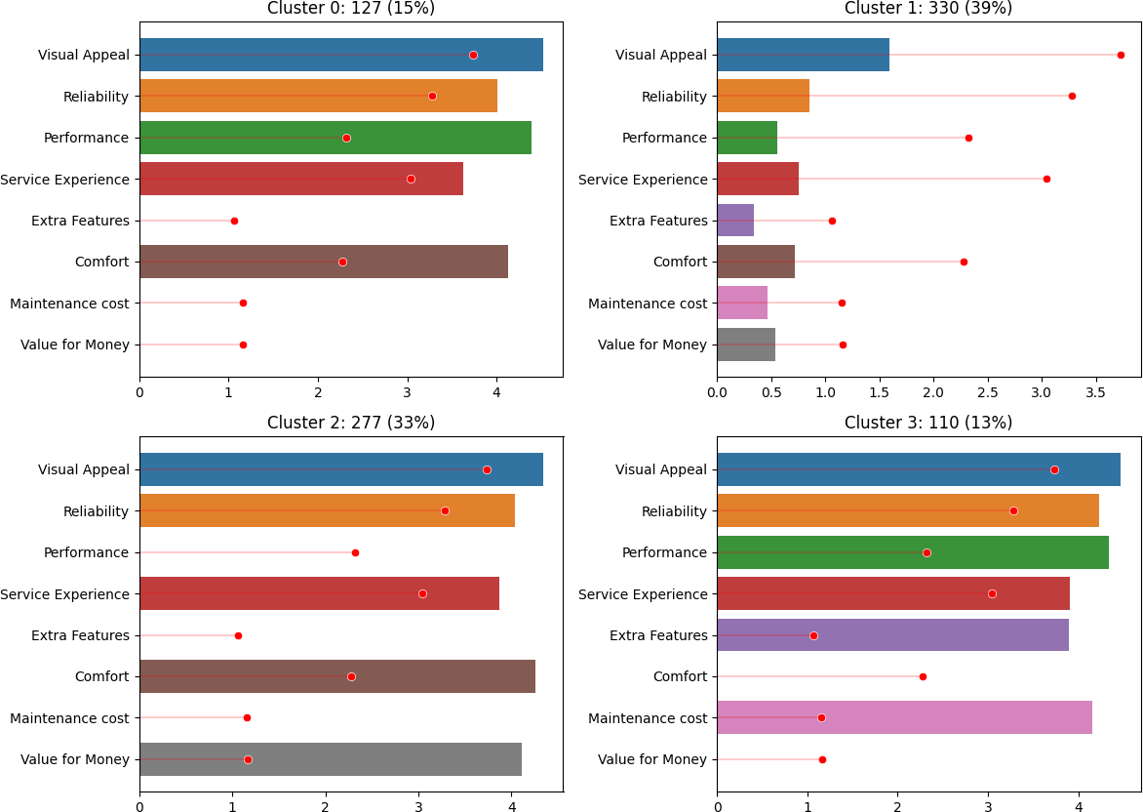

### Figure6.1Segmentprofileplotforthefour-segmentsolution

The accompanying Figure 6.2, utilizing principal components, further emphasizes these differences.Notably,Segment1,despitebeingthelargestsegment,lacksspecificopinions,

making them unique in their lack of satisfaction.These detailed insights play a pivotal role in shapingourstrategy,ensuringourelectricvehiclesalignpreciselywiththediversevaluesand priorities of each segment, thus informing our market offerings accurately.

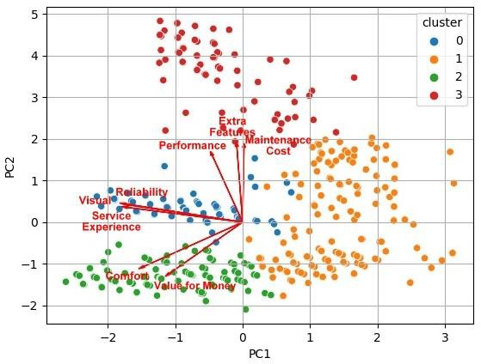

**Figure6.2Segmentseparationplotusingprincipalcomponents1and2**

## DescribingSegments

Thissectionprovidesacomprehensiveoverview basedontheinsightsderivedfromvarious mosaic plots and graphical representations. In Figure 6.3, the mosaic plot illustrates that all segments predominantly use electric vehicles for daily commuting, with limited usage for tours,occasionalcommuting,andleisurerides.MovingtoFigure6.4,theplotdelineatesthe ownership duration of electric vehicles among segments. Segment 1 stands out, owning

electric vehicles for more than a year, while Segment 0 has no prior ownership experience. Segment2membersmoderatelyownvehiclesrangingfromlessthan3monthstooverayear, and Segment 3 consumers have owned electric vehicles for a few days to less than 3 months.

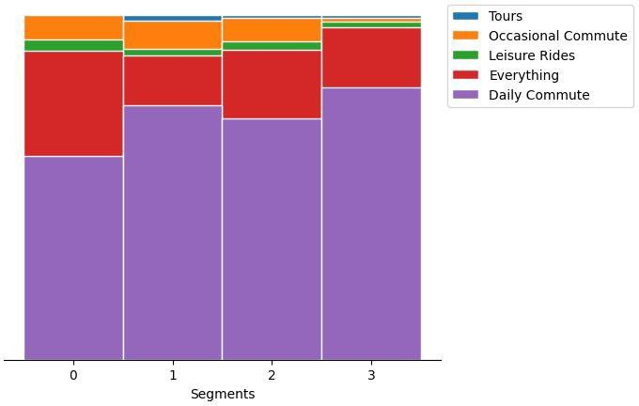

### Figure6.3Mosaicplotshowcasingelectricvehicleusagepatternsacrosssegments

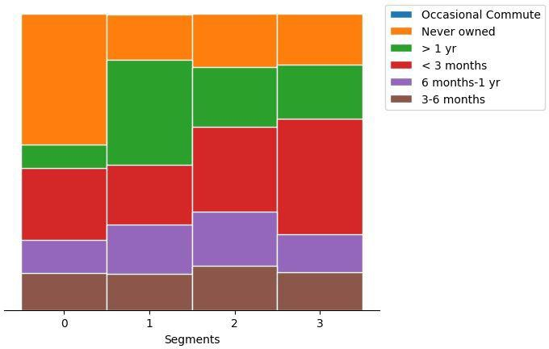

**Figure6.4Mosaicplotdepictingtheownershipdurationofelectricvehiclesacross segments**

Figure6.5delvesintothedistancescoveredbyconsumers,indicatingthatallsegments

predominantlyuseelectricvehiclesforcommuting,withmostuserscoveringdistancesbelow 5000 kms.Asmall portion falls in the 5000 to 10000 kms range, aligning with their

commutingneeds.

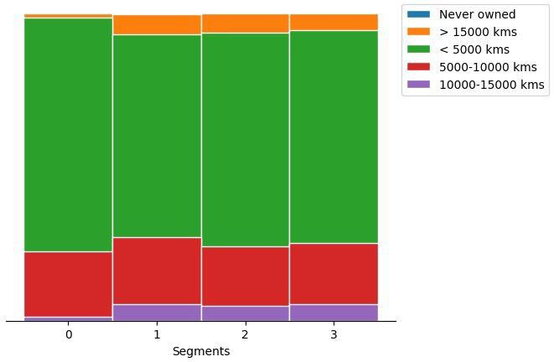

### Figure6.5Mosaicplotoutliningconsumersdistancecoveredbyconsumersonelectric vehicles

Figure6.6exploresconsumersentiments,revealingthatallsegments,exceptSegment1, exhibit positive sentiments. Segment 1 consumers stand out with negative sentiments,

indicatingdissatisfactionacrossvariousaspects.

Figure6.7,aparallelboxandwhiskerplot,emphasizessignificantdifferencesinaverage

ratingsamongsegments.Specifically,Segment1consumersexpressdissatisfactionacrossall perceptions, leading to lower overall ratings. These graphical representations offer nuanced

insightsintoconsumerbehaviors,sentiments,andpreferences,guidingourstrategicdecisions for a more tailored approach in the electric vehicle market.

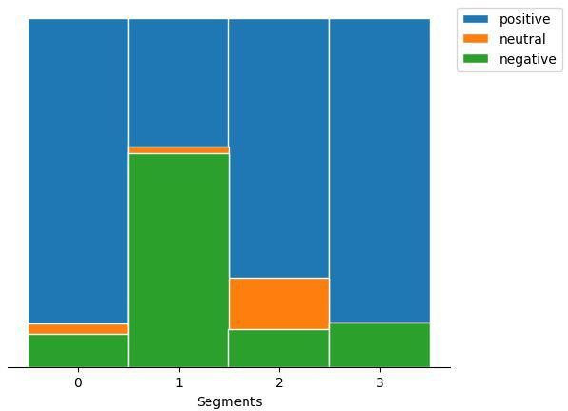

### Figure6.6Mosaicplotdisplayingconsumersentimentstowardselectricvehicles

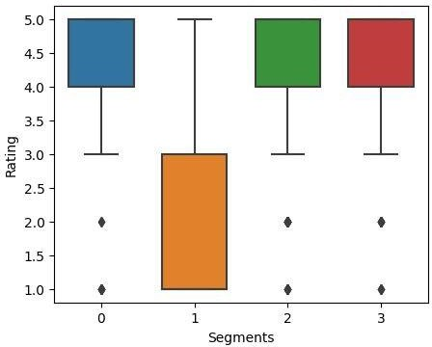

**Figure6.7Parallelbox-and-whiskerplotshowcasingconsumerratingsacrosssegments**

Inanalyzingthetechnicalspecificationsofelectricvehiclesacrosssegments,distinctpatterns emerge. Segment 0 showcases a higher price range, emphasizing a preference for premium

electricvehicleswithin thisgroup.Thisisreflected in Figure6.8 (a), aparallel box and whiskerplotrepresentingthepricerange.Conversely,Segment1exhibitsalower price

range, indicating a focus on morebudget-friendly options. Segment 2 and Segment 3 also emphasizeaffordability,albeitwithslightdifferences.Thesefindingsalignwithconsumer preferences, highlighting varied economic considerations within the market.

Moving to riding range, Segment 0 stands out with a higher average riding range, suggesting apreferenceforelectricvehicleswithextendedrange,portrayedinFigure6.8(b).Incontrast,

Segment1andSegmentfocusonmoderaterangesfordailycommuting.Segment3falls between, catering to consumers desiring slightly longer distances, highlighting nuanced commuting needs.

Consideringtopspeed,Segment0andSegment3optforvehicleswithhigherspeeds,while Segment 1 and Segment 2 prioritizelower speeds suitable for city commuting.Thesetrends are depicted in Figure 6.8 (c).

Weightplaysapivotalrole,whereSegment0andSegment1favorslightlyheaviervehicles, as represented in Figure 6.8 (d). Segment 2 and Segment 3 lean towards lighter options, accommodating diverse user preferences for vehicle weight.

Lastly,batterychargingtimedemonstratesanoteworthydifference.Segment0andSegment 3 opt for slightly longer charging durations, depicted in Figure 6.8 (e), emphasizing the

convenienceofovernightcharging.Segment1andSegment2prioritizefastercharging, catering to users seeking quicker turnaround times for their electric vehicles.

These technical specifications, visually represented in respective figures, underscore the nuancedpreferencesandprioritiesofeachsegment,shapingthelandscapeoftheelectric vehicle market in India.

|  |  |
| --- | --- |
| (a) | (b) |
| (c) | (d) |
| (e) | (f) |

**Figure6.8.Parallelbox-and-whiskerplotoftechnicalspecificationofelectricvehicleby segment**

# SelectionofTargetSegment

Inthestrategicselectionofourtargetsegmentfortheelectricvehiclemarket,Segment1and Segment 2 stand out as potential focal points. Segment 1, encompassing 39% of consumers, represents a vast market base with diverse perceptions and preferences. This segment's

varying sentiments, as revealed through our analysis, signify their specific demands and priorities. Understanding theirunique perceptions, such asdissatisfaction acrossmultiple aspects,presentsanopportunity.Addressingtheseconcernsdirectlycanleadtoimproved customer satisfaction and brand loyalty within this significant market share.

Segment 2, comprising 33% of consumers, presents another enticing opportunity.Their distinct perceptions, including valuing visual appeal, reliability, service experience, and comfort,shapetheirexpectations.Thissegment'sfeedbackprovidesinvaluableinsights,

aidinginthecustomizationofourelectricvehiclestoalignwiththeirspecificperceptions.By cateringtotheirpreferences,suchas emphasizing valueformoney,ourofferingscan createa strong resonance within this consumer group.

Uponcarefulanalysis,Segment1offersauniquechallengeandopportunity.By

comprehensivelyaddressingtheirdissatisfactionpointsandcraftingelectricvehiclesthat specifically counter these concerns, our strategy can yield remarkable results.

Simultaneously,understandingSegment2'spositiveperceptionsprovidesafoundationfor enhancing these features further, ensuring a positive customer experience and reinforcing brand loyalty.

Incorporatingtheseperceptionswithintherespectivesegments,ourstrategywillfocuson

refiningexistingfeatures,addressingdissatisfactionpoints,andenhancingpositiveelements. By aligning our electric vehicles with the distinct expectations of Segment 1 and Segment 2, our approach will be finely tuned to meet the specific needs of these segments, ensuring a

competitiveedgeandsustainedmarketgrowth.

# CustomizingtheMarketingMix

Inourelectricvehiclemarketstrategy,customizingthemarketingmixisparamountfor appealing to Segment 1 and Segment 2, our identified target segments. For Product

Customization, we plan to enhance features tailored to the specific desires of each segment. Addressingdissatisfactionpoints,suchasimprovingperformanceandserviceexperiencefor Segment 1, and emphasizing visual appeal and value for money for Segment 2, is central to

productrefinement.Diverseofferingswithineachsegmentensureabroadspectrumof choices, aligning with varied tastes and budgets.

PriceCustomizationinvolvessettingcompetitiveandflexiblepricingstructures.Segment1 will benefit from affordable options, while Segment 2 might accept a slightly higher price point for value-added features. Promotion Customization demands targeted advertising,

focusing on reliability and service improvements for Segment 1, and aesthetics and affordabilityforSegment2.Tailoredpromotionaleventsandonlinecampaignsfurther engage these segments effectively.

In terms of Place Customization, we'll establish accessible distribution channels in urban areasforSegment1andinsuburbanandsemi-urbanregionsforSegment2.Strengthening our online presence ensures seamless online purchasing experiences, emphasizing virtual

showroomsandcustomersupportplatforms.Additionally,PeopleandProcessCustomization involves training customer service representatives to address segment-specific concerns

empathetically.Efficientprocesses,streamlinedforcustomizationrequestsandservice appointments,enhancecustomersatisfactionandbrandloyalty.Thistailoredapproach

ensuresourelectricvehiclesresonatewiththedistinctneedsofSegment1andSegment2, fostering market relevance and customer preference.

# PotentialEarlyMarketCustomerBase

In the analysis of the potential early market customer base, two primary segments emerge: Segment 1, encompassing 330 members (39% of consumers), and Segment 2, comprising277members(33%ofconsumers).Analyzingthe pricerangedata,thelogicaltargetprice for Segment1fallsbetween₹51,094and₹1,67,844,whileforSegment2,itrangesfrom₹51,094 to ₹1,37,890.

Calculating the potential sales (profit) in this early market scenario involves multiplying the number of potential customers in each segment by our targeted price range. For instance, if our target price for Segment 1 is set at ₹1,20,000 the potential profit from this segment alone wouldamountto₹39.60crores.Similarly,forSegment2withatargetpriceof₹1,10,000,the potential profit would be ₹30.47 crores.

Segment1demonstratesthelargerpotential,withasignificantlyhighermarketshareanda broader customer base, making it a primary focus for our early market penetration efforts.

Thesecalculatedpotentialprofitsunderscorethesubstantialmarketopportunitywithinthese segments, guiding our strategic decisions effectively.

# MostOptimalMarketSegments

In the context of selecting the most optimal market segment for our electric two-wheeler vehicles, thoroughanalysisand evaluation havepointed to Segment 1 asthe ideal choice. Representing39%ofconsumers,thissegmentboastssignificantopportunitiesandalarge customer base, making it a strategic target for market penetration. Its substantial market potential, coupled with its balanced blend of technical specifications and price range,

positionsitasthemost promisingmarketsegmentforourelectricvehicles.

TherecommendedtechnicalspecificationrangeforSegment1,presentedinTable10.1, ensuring alignment with the diverse needs and preferences of the market:

### Table10.1Technicalspecificationofelectricvehicletwo-wheelerforsegment1

|  |  |
| --- | --- |
| **Specification** | **RecommendedRange(inINR)** |
| Price | 70,688 – 1,29,063 |
| Riding range | 89 -180 km |
| Topspeed | 58-116kmph |
| Weight | 76 -120 kg |
| Batterycharging time | 3 -5 hours |
| Ratedpower | 1200 -5500W |

Thiscomprehensiveanalysisensuresourmarketentrystrategyisfinelytunedtocatertothe demands and expectations of the chosen segment, setting the stage for a successful and

sustainableventureinto theelectricvehiclemarket.

# Conclusion

Insummary,ourin-depthanalysisofIndia'selectricvehiclemarketledustoidentify Segment1astheoptimaltarget.Withasignificant39%consumerbase,thissegment represents a substantial market opportunity. By tailoring our electric two-wheeler

specificationstomeetthe preferencesofthissegment,weensureourproducts align

seamlesslywiththedemandsofalargecustomer base.Thisstrategicdecisionisgroundedin

athoroughunderstandingofmarketsegmentation,consumerbehavior,andtechnical specifications.

Theseinsightsprovideacleardirectionforourmarketentry,emphasizingprecisionand relevance in both product development and marketing strategies. Moving forward, this

approachequipsuswithasolidfoundation,ensuringourofferingsresonateeffectivelywithin India's evolving electric vehicllandscape.

# References

SocietyofManufacturesofElectricVehicles,(2023,October),<https://www.smev.in/ev-industry>

Bikewale,(2023,October),<https://www.bikewale.com/>

S.Dolnicar,B.Grun,F.Leisch,MarketSegmentationAnalysis,SpringerOpen,Management for Professionals, 2018

M.Dilip Kumar

An electric vehicle (EV) operates using electric motors for propulsion, drawing power either from an external

source via a collector system or autonomously from a battery. Some EVs use solar panels or convert fuel into electricity through fuel cells or generators. EVs encompass a wide range of vehicles, including road and rail vehicles, boats, aircraft, and even spacecraft.

The concept of EVs dates back to the mid-19th century when electric propulsion was favored for its comfort

and ease of use, surpassing the early gasoline engines of the time. Although internal combustion engines dominated car and truck propulsion for about a century, electric power continued to be widely used for other vehicles like trains and smaller forms of transport.

In recent years, EVs have experienced a resurgence due to advancements in technology, a shift toward

renewable energy, and efforts to reduce the environmental impact of transportation, particularly in combating climate change. Electric vehicles are considered one of the top 100 solutions for addressing climate change, as outlined by Project Drawdown.

In India, the electric vehicle market is still in its early stages, accounting for less than 1% of total vehicle

sales, but it has the potential to grow to over 5% within a few years. Currently, there are over 500,000 electric two-wheelers and several thousand electric cars on Indian roads. The growth of the industry has been closely

tied to government incentives. Major players, such as Hero Eco, Ather, Electrotherm, Avon, Lohia, and Ampere, continue to drive innovation and progress.

Most electric vehicles on Indian roads, over 90%, are low-speed electric scooters (with speeds below 25 km/h) that do not require licenses or registration. These scooters predominantly use lead-acid batteries to remain

affordable, but battery reliability and lifespan have been major obstacles to broader adoption, even with government subsidies.

Manufacturers have made strides in installing charging infrastructure, though progress has been slow.

Companies like Lohia and Electrotherm have developed electric three-wheelers, while Ampere and Hero have entered the electric bicycle market. Additionally, a growing number of e-rickshaw manufacturers have been catering to last-mile connectivity needs.

The electric vehicle industry in India is poised for growth, but incentives will play a crucial role in accelerating adoption. With the potential impact of the FAME-2 scheme, the industry may experience significant advances in both volume and technology.

Market Overview:

As stated earlier in India the electric vehicle industry is in nascent stages, the majority of

the automobile market is dominated by petrol/diesel engine automobiles. The global supply of electric vehicles is also rising rapidly with the increase risk of climate change. It

is a very good opportunity for Indian EV manufacturers to enter the market. The rising

EV’s in the span of 10 years is shown as below:

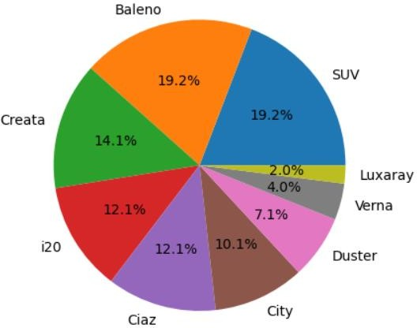

According to The data majority of the share is held by Baleno, and SUV.

The pie chart below represents the present market share of all the major automobile manufacturers in India.

The Indian Electric Vehicle Market was valued at USD 5 billion in 2020, and it is expected

to reach USD 47 billion by 2026, registering a CAGR of above 44% during the forecast period (2021-2026).

The Indian Electric Vehicle Market has been impacted by the outbreak of the COVID-19 pandemic due to supply chain disruptions and halt of manufacturing units due to continuous

lockdowns and travel restrictions across the county. However, the electric vehicle (EV) market is still in its nascent stage in India. It is expected to grow at a much faster rate

during the forecast period due to various government initiatives and policies.

E-commerce companies (Amazon, for example) are launching initiatives to use e-Mobility for last-mile deliveries to reduce carbon footprint. India is experimenting with e-Mobility

for public transport, and the country has deployed electric inter-city buses across some

major cities. In addition, state governments are also playing an active role in the deployment of policies encouraging the usage of EVs. For instance,

* Kerala aims to put one million EV units on the road by 2022 and 6,000 e-buses in public transport by 2025.
* Telangana aims to have EV sales targets for 2025 to achieve 80% 2- and 3-

wheelers (motorcycles, scooters, auto-rickshaws), 70% commercial cars (ride- hailing companies, such as Ola and Uber), 40% buses, 30% private cars, and 15%

electrification of all vehicles.

* Bengaluru has recently bought 90 electric buses for in city transportation for

BMTC and is looking to go all electric by 2023.

The EV market in India has gained significant momentum after the implementation of the

FAME India scheme with its aim of shifting toward e-mobility in the wake of growing

international policy commitments and environmental challenges. Moreover, India offers the world’s largest untapped market, especially in the electric two-wheeler segment. As 100% foreign direct investment is allowed in this sector, the automatic route market is

expected to gain momentum during the forecast period.

An electric vehicle is one that operates on an electric motor instead of an internal

combustion engine, which generates power by burning a mix of fuel and gases. Therefore,

an electric vehicle is seen as a possible replacement for the current-generation automobile

in the near future to address environmental challenges. The report covers the latest trends and technologies followed by the COVID-19 impact on the market.

Market Segmentation:

The Indian Electric Vehicle Market is segmented by Vehicle Type and Power Source.

By Vehicle Type, the market is segmented into Passenger Cars, Commercial Vehicles, and Two- and Three-wheelers.

By Power Source Type, the market is segmented into Battery Electric Vehicle, Plug-in Electric Vehicle, and Hybrid Electric Vehicle.

India is the second most populated country in the world after China, and just like China,

which has the largest electric bus fleet in the world. India is also pushing hard for the electrification of buses. Many state governments have already started procuring electric

buses from Chinese and local electric bus manufacturers.

With the growing need for controlling GHG (Greenhouse gases) emissions emitted by vehicles, the government is encouraging the use of electric-powered vehicles across

various states, boosting the demand for electric buses in India. The market is driven by factors such as the increase in domestic manufacturing, rapid urbanization, and a rise in environmental awareness. For instance,

* In February 2020, the Union Transport minister inaugurated India's first inter- city electric bus service. These buses were manufactured by Mitra Mobility

Solution, with a range of 300 km on a full charge.

Many local bus manufacturers who are in collaboration with some Chinese manufacturers are trying to cater to the rising demand for electric buses in India. For instance,

* In 2019, Foton PMI was planning to invest around INR 500 crore in a joint venture with Beiqi

Foton Motor Co. of China to manufacture electric buses in India. The company has already given five electric buses to one of the airlines for internal operations.

Optimistic Growth Of Electric Two-wheeler Vehicles :

With transportation still being a challenge in India, a lot of people in these segments look

forward to the two-wheeler industry in India. As a result of the surging pollution, the national government has launched stringent policies to curb vehicular emissions. In

particular, the jump from Bharat Stage V (BSV) to BSVI emission standards is expected to benefit the Indian electric scooter and motorcycle market, by raising the prices of petrol-driven two-wheelers by 7–15%. From 1st April 2020 onward, automakers are only

allowed to sell BSVI-compliant vehicles in the nation, driving the push toward electric

variants.

For extracting the maximum revenue from the rapidly growing Indian electric scooter and motorcycle market, original equipment manufacturers (OEMs) are expanding their

facilities. For instance,

* In January 2020, Ather Energy Pvt Ltd announced intentions to build a 400,000-sq-ft factory in

Hosur, Tamil Nadu, which would have an annual output of 1 lakh units. Currently, the company operates one manufacturing plant in Bengaluru, which has a capacity of 25,000 units. The idea of the company behind an additional facility is meeting the rising demand for electric two-wheelers in India.

In the same vein, Okinawa AutoTech Pvt Ltd invested USD 28.4 million (INR 200 crore) for its second manufacturing plant in May 2019. To be developed for electric two-wheeler vehicles in

Rajasthan and planned to be commissioned in early 2020–21, the manufacturing plant will have an annual output of 10 lakh units.

Furthermore, the availability of a considerable number of electric two-wheeler models,

their low cost, as well as their availability as a substitute for conventional fuel-based vehicles. These aforementioned factors are fuelling the demand in the Indian electric vehicle market.

Here we can compare all variables with all the other variables.

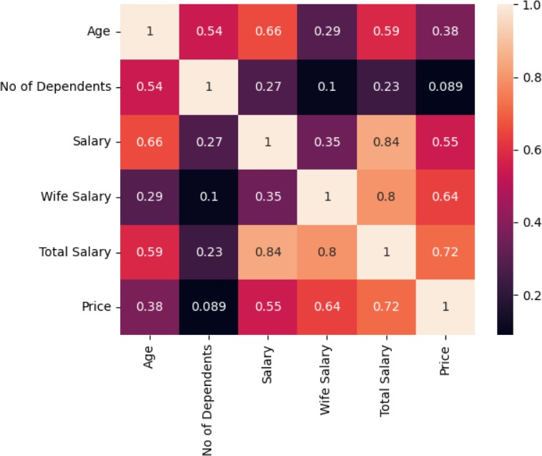

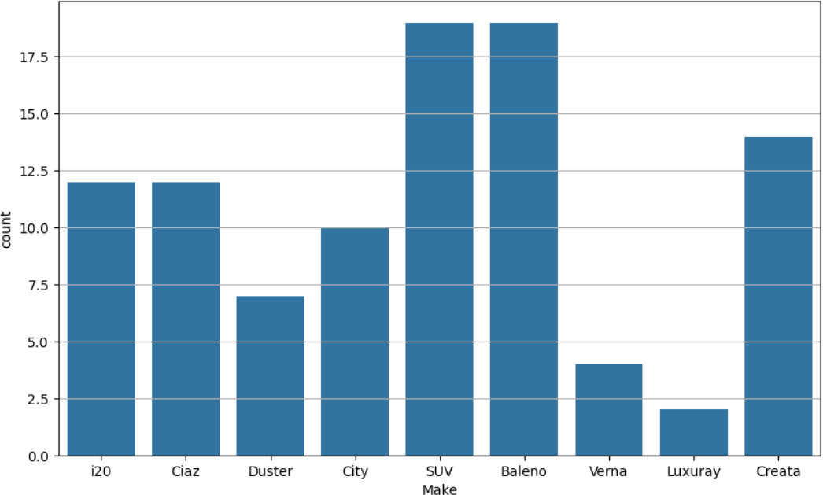

Here the count of the models using in India .

K-Means Clustering:

Clustering:

Clustering is one of the most common exploratory data analysis techniques used to get an intuition about the structure of the data. It can be defined as the task of identifying subgroups in

the data such that data points in the same subgroup (cluster) are very similar while data points in different clusters are very different. In other words, we try to find homogeneous subgroups within

the data such that data points in each cluster are as similar as possible according to a similarity measure such as Euclidean-based distance or correlation-based distance. The decision of which similarity measure to use is application-specific.

Clustering analysis can be done on the basis of features where we try to find subgroups of

samples based on features or on the basis of samples where we try to find subgroups of features based on samples.

**K-Means Algorithm**

K-Means clustering is an unsupervised machine learning algorithm that groups similar data points into a specified number of clusters (k). It aims to partition the dataset in such a way that data points within the same cluster are more similar to each other than to those in other clusters. Each

cluster is represented by a central point, or centroid, which is the mean of all the points in the cluster. The algorithm iteratively adjusts these centroids and reassigns data points to clusters based on proximity until it finds a stable grouping. K-Means is commonly used for tasks like customer segmentation, image compression, and pattern recognition due to its simplicity and

efficiency, although it requires pre-defining the number of clusters and is sensitive to initial centroid selection and data distribution.

**The way k means algorithm works is as follows:**

1. Specify number of clusters K.
2. Initialize centroids by first shuffling the dataset and then randomly selecting K data points for the centroids without replacement.
3. Keep iterating until there is no change to the centroids. i.e. assignment of data points

to clusters isn’t changing.

**Packages/ Tools used:**

1. NumPy: To calculate various calculations related to arrays.
2. Pandas: To read or load the datasets.
3. Matplot : To visualize the dataset
4. Seaborn : To advance visualize the dataset

We have considered a dataset which contains data regarding the spending habits of people regarding type of cars etc.

With respect to the above data the population can be segmented on the basis of age,

marital status and salary, each of these segments should be targeted separately as they have different requirements.



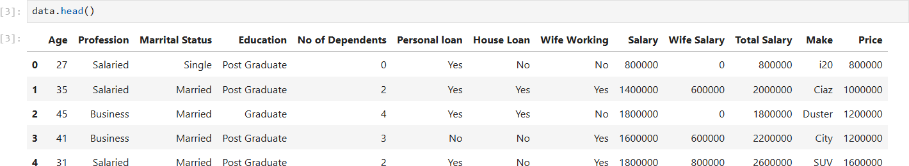

**Data Preprocessing :**

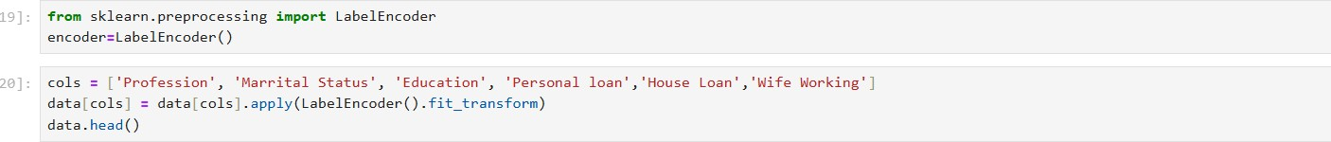

After the data preprocessing , we can proceed with the model training with the clustering algorithm K-Means

After the data is pre-processed, we can proceed with segmentation of population. We calculate the number of clusters by using the elbow method.

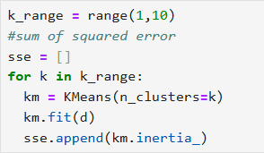

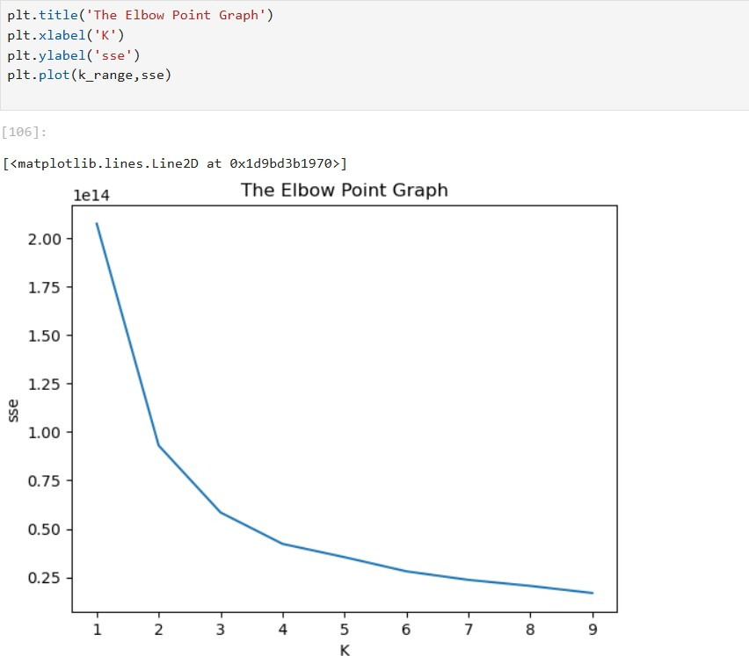

We get the number of clusters as 3.

The clustering of age vs price is as follows. As we can see that as age increases the price of the car also increases. This can be justifying as older people tend to be in high paying Jobs.

**Observations:**

* We found that 3 clusters groups can be formed from the data given (based on

price of the vehicle) using the K-Means algorithm and Elbow Point Method

* While looking at the patterns, we find that as the Age increases the cost of the

vehicle also rises.

* Also, amount spent on the car goes up with the number of dependents. The

same is true for salary field too.

* The visualizations provided gives a clear idea about the patterns.